Royal British Legion – Peaslake Branch

The Peaslake Branch was first established in 1923. Until recently the Branch had club premises in the village which were built with the help and support of local people. The club was sold, and the money raised is held in a trust fund arranged by TRBL. The interest received from the trust fund is donated each year to TRBL homes around the country.
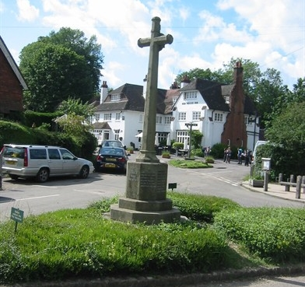
The branch holds regular meetings and events at the village pub and hotel – The Hurtwood Inn, who are kind enough to provide a room when needed.
Membership is open to all. Men and women, whether they have served in the armed forces or not.
Contact Paul Carter@metronet.co.uk

